Week-6 HW-2

Q32:

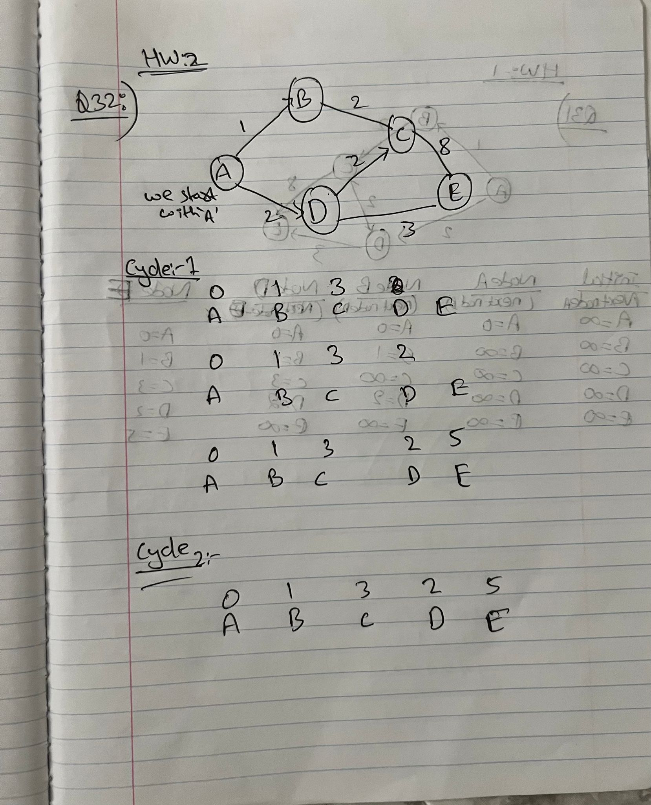

ChatGPT code:

Test code:

Output:

